**Question-1:-** Use ps to search for the “systemd” process by name.

Ans :-“systemd” is a daemon process which starts as soon as the computer starts and continue till the system is shutdown. It was a replacement of **init** daemon. So it always has a **PID 1**.

Command:-**ps -fC init🡪**’ps’ is used to view running process in a system. ‘-C’ is used to search a process by its name or command. And init is the name of process.(init is replaced by system).

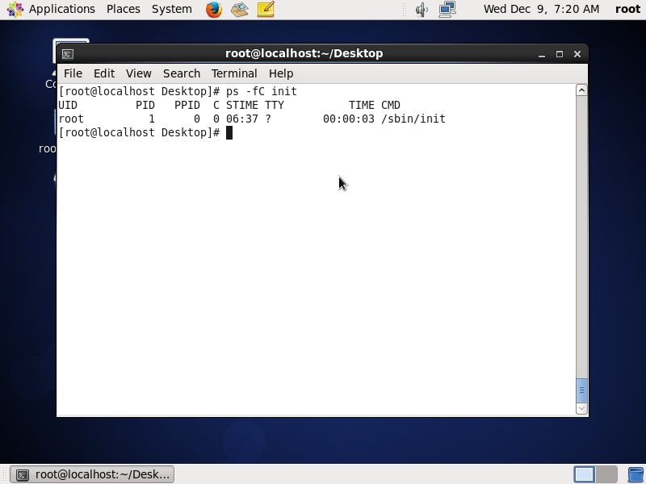

Fig shows ps to search a process by its name

**Question-2:-** Find out your terminal name.Using your terminal name, use ps to find all processes associated With your terminal.

Ans:-

Command:-**tty🡪**is used to display terminal name

**ps -e🡪** is used to display all process running in all terminals

**ps -t**🡪is used to display process running in current terminal

**ps -t2**🡪is used to display process running in tty2

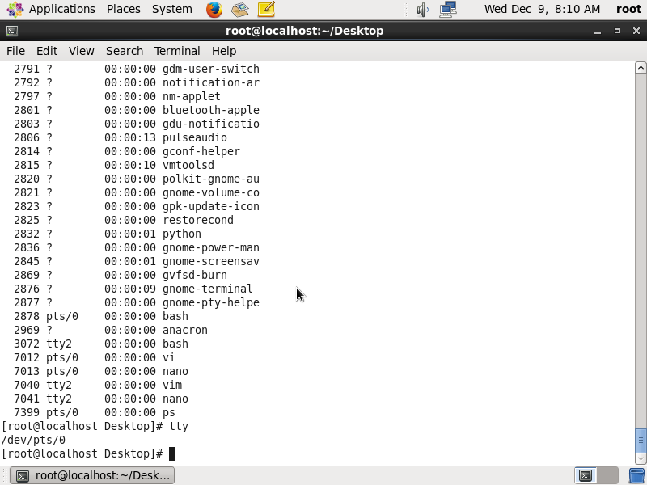

fig showing current terminal name and all process running in all terminals

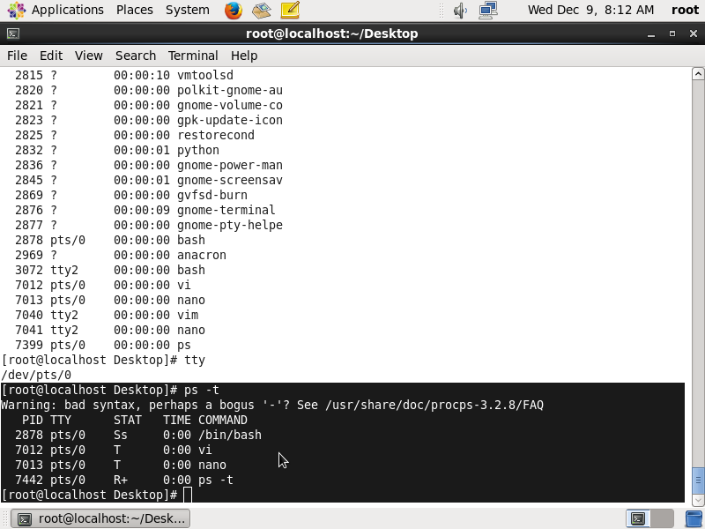

Fig showing process running in current terminal

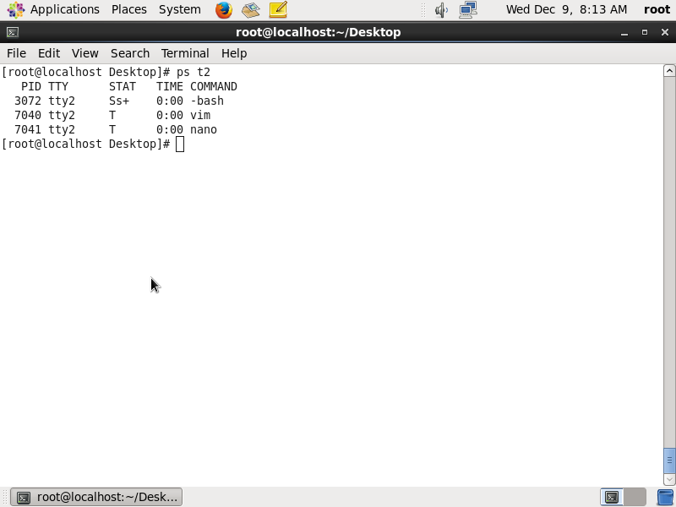

Fig showing processes running in tty2

**Question-3:-** Check and note the process id of your shell(from the output of the above command). Also, note the parent process id of your shell.

Ans:-

Command:-**echo $PPID🡪**Displays current shell PPID

**pstree -p $PID(value)🡪**displays process associated with this pid

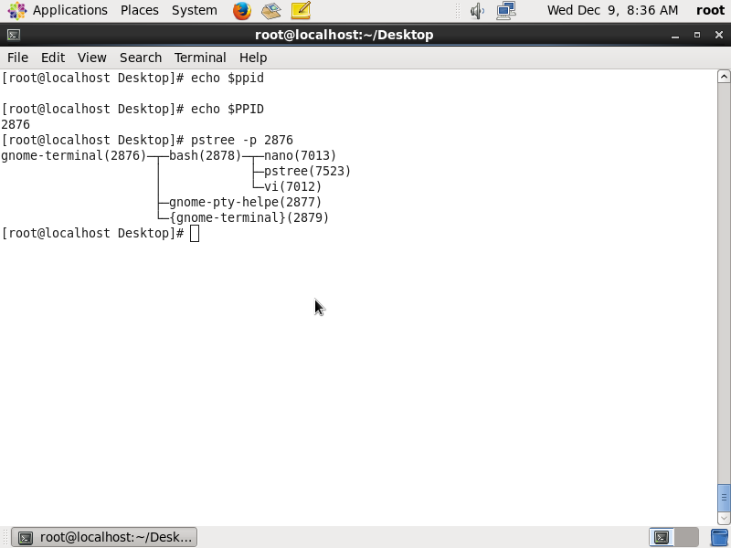

Fig shows pid and ppid of current terminal

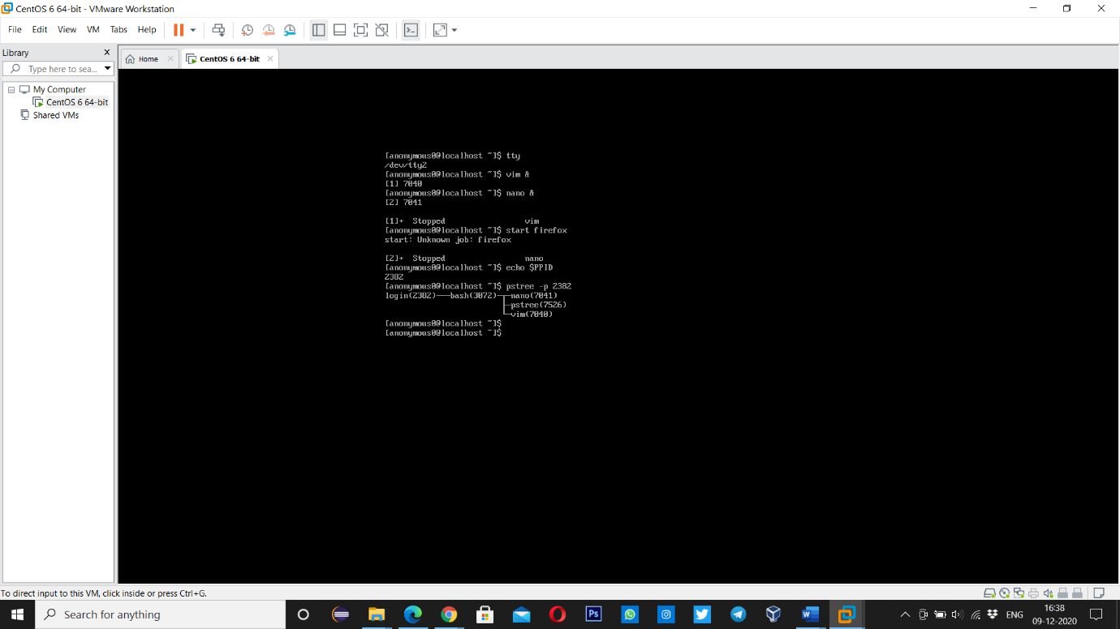

Fig shows pid and ppid of tty2

**Question-4:-** Start 3 instances of “sleep 123” as background processes.

Ans:-

Commad:- **sleep 123 &🡪** create an instance of sleep 123 in the background

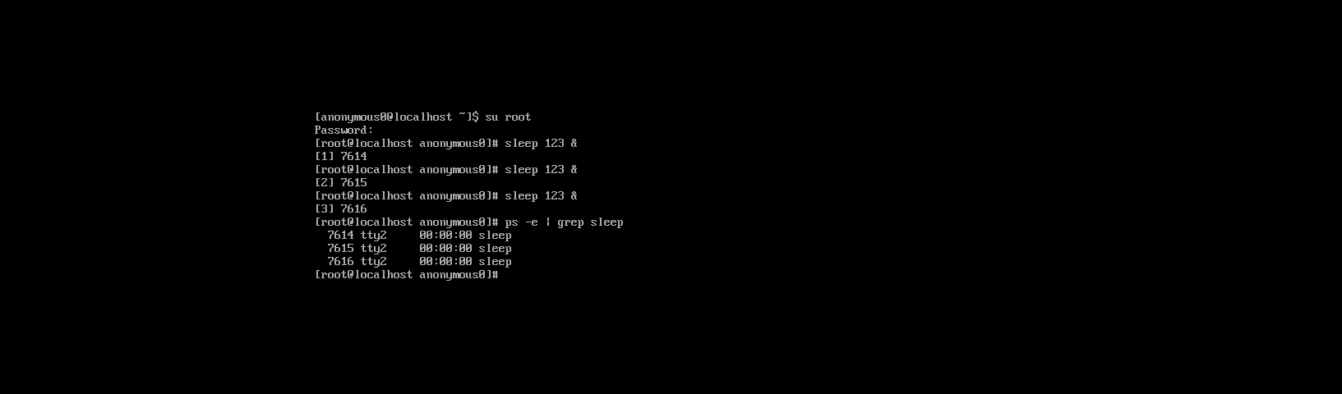

fig shows creation of sleep 123 instances in the background.

**Question-5:-** Check and note the process id’s of all sleep processes

Ans:-

Command:-**ps -e | grep sleep🡪** shows all the process id’s of sleep instances.



Fig shows process id’s of all sleep processes

**Question-6:-** Display only those three sleep processes in top. Then quit top.

Ans:-

Command:-**top -p pid,pid,pid 🡪 top** command is used to show the **Linux** processes. It provides a dynamic real-time view of the running system. Usually, this command shows the summary information of the system and the list of processes or threads which are currently managed by the **Linux** Kernel.

